- \Operation\Monitoring, ambient air\ Monitoring, ambient air
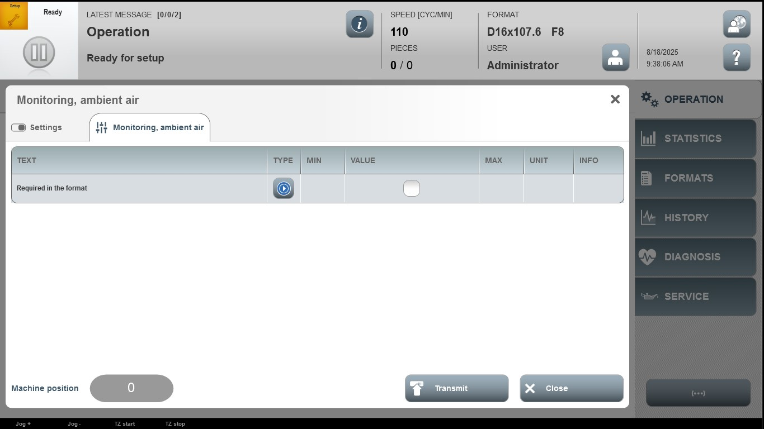

Acceptance criterion | Limits | Pass / Fail: Dev-No. | Date | Initials

